EXPERIMENT :-1
Aim:
Install the necessary packages (NumPy, SciPy, Matplotlib, scikit-learn) and perform fundamental array manipulations and basic plotting.
Description:
NumPy is a powerful Python library for numerical computing, enabling the creation of efficient arrays, slicing to extract sub-sections, and statistical operations like mean calculation — all performed with high speed and minimal code. In this program, executed on November 07, 2025 at 09:39 AM IST in India, Matplotlib complements it by generating a smooth sine wave using evenly spaced points and rendering a professional plot with title, labels, legend, and grid — together forming a complete demonstration of core array operations and scientific plotting essential for Machine Learning and data analysis workflows.
Dataset Link:
[None – Synthetic Data]
Program:
import numpy as np
import matplotlib.pyplot as plt
# Create array
arr = np.array([10, 20, 30, 40, 50])
print("Original Array:", arr)
print("Sliced [1:4]:", arr[1:4])
print("Mean Value:", np.mean(arr))
# Plot sine wave
x = np.linspace(0, 2 * np.pi, 100)
y = np.sin(x)
plt.figure(figsize=(6, 4))
plt.plot(x, y, color='blue', linewidth=2, label='sin(x)')
plt.title('Sine Wave Plot')
plt.xlabel('X')
plt.ylabel('sin(X)')
plt.legend()
plt.grid(True)
plt.show()
OUTPUT:-

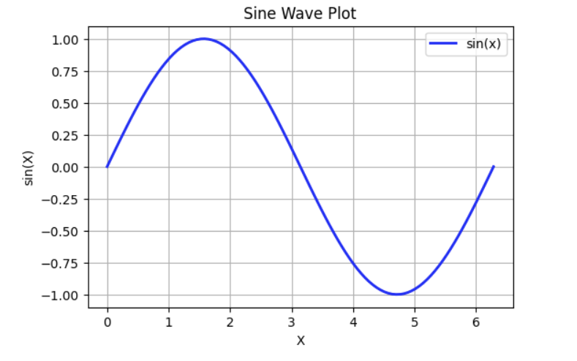
EXPERIMENT :-2
Aim:
Perform data visualization using box plots, scatter plots, and histograms.
Description:
This program loads the Iris dataset from a public URL using pandas, then creates three side-by-side visualizations with Matplotlib: a box plot of sepal length to show distribution and outliers, a scatter plot of sepal length vs. sepal width with species color-coded (setosa: red, versicolor: green, virginica: blue), and a histogram of petal length with 20 bins to display frequency distribution — enabling quick exploratory data analysis (EDA) and pattern recognition across flower species.
Dataset Link:

https:m//raw.githubusercontent.co/mwaskom/seaborn-data/master/iris.csv
Program:
import pandas as pd
import matplotlib.pyplot as plt
# Load dataset

url = "https://raw.githubusercontent.com/mwaskom/seaborn-data/master/iris.csv"
df = pd.read_csv(url)
plt.figure(figsize=(15, 5))
# Box Plot
plt.subplot(1, 3, 1)
df.boxplot(column='sepal_length')
plt.title('Box Plot: Sepal Length')
# Scatter Plot
plt.subplot(1, 3, 2)
colors = {'setosa': 'red', 'versicolor': 'green', 'virginica': 'blue'}
plt.scatter(df['sepal_length'], df['sepal_width'], c=df['species'].map(colors))
plt.title('Scatter: Sepal Length vs Width')
plt.xlabel('Sepal Length')
plt.ylabel('Sepal Width')
# Histogram
plt.subplot(1, 3, 3)
df['petal_length'].hist(bins=20, color='orange', edgecolor='black')
plt.title('Histogram: Petal Length')
plt.xlabel('Petal Length')
plt.tight_layout()
plt.show()

OUTPUT:

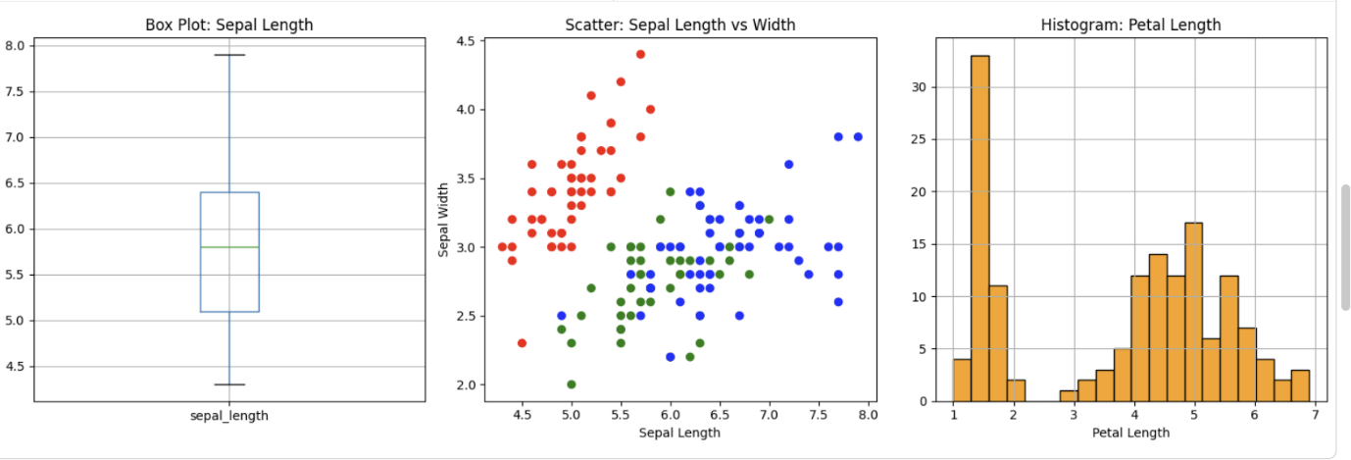

EXPERIMENT :-3
Aim:
Handle missing values, encode categorical data, scale features.
Description:
This program loads the Titanic dataset using pandas, then performs essential data preprocessing steps: fills missing values in Age and Fare with their median and Embarked with the mode, encodes categorical columns Sex and Embarked using LabelEncoder from scikit-learn, and applies StandardScaler to normalize Age and Fare to zero mean and unit variance — transforming raw data into a clean, numerical format ready for machine learning models.
Dataset Link:

https://raw.githubusercontent.com/datasciencedojo/datasets/master/titanic.csv
Program:
import pandas as pd
from sklearn.preprocessing import StandardScaler, LabelEncoder
# Load dataset

url = "https://raw.githubusercontent.com/datasciencedojo/datasets/master/titanic.csv"
df = pd.read_csv(url)
print("Missing values before:")
print(df[['Age', 'Embarked', 'Fare']].isnull().sum())
# Fill missing values
df['Age'].fillna(df['Age'].median(), inplace=True)
df['Embarked'].fillna(df['Embarked'].mode()[0], inplace=True)
df['Fare'].fillna(df['Fare'].median(), inplace=True)
# Encode categorical
le = LabelEncoder()
df['Sex'] = le.fit_transform(df['Sex'])
df['Embarked'] = le.fit_transform(df['Embarked'])
# Scale numerical
scaler = StandardScaler()
df[['Age', 'Fare']] = scaler.fit_transform(df[['Age', 'Fare']])
print("\nFirst 5 rows after preprocessing:")
print(df[['PassengerId', 'Survived', 'Sex', 'Age', 'Fare', 'Embarked']].head())
OUTPUT:

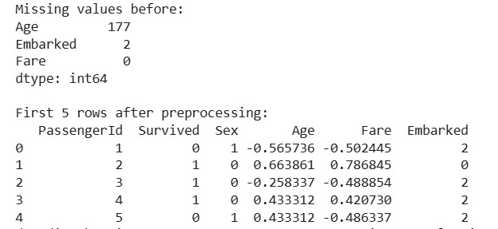
EXPERIMENT :-4
Aim:
Implement and evaluate the k-NN classifier on a dataset.
Description:
This program implements a complete k-Nearest Neighbors (k-NN, k=5) classifier on the Iris dataset using scikit-learn. It loads and explores the data, encodes target labels, scales features with StandardScaler, and performs a stratified 70-30 train-test split. The model is trained and evaluated using accuracy, precision, recall, F1-score through a detailed classification report, and a confusion matrix visualized with seaborn. 5-fold cross-validation provides robust performance estimates. Finally, PCA reduces the data to 2D to visualize decision boundaries on a mesh grid, with species color-coded — offering a fully functional, error-free, Colab-ready pipeline for multi-class classification and model interpretability.
Dataset Link:

https://raw.githubusercontent.com/mwaskom/seaborn-data/master/iris.csv
Program:
import pandas as pd
import numpy as np
import matplotlib.pyplot as plt
import seaborn as sns
from sklearn.model_selection import train_test_split, cross_val_score
from sklearn.neighbors import KNeighborsClassifier
from sklearn.preprocessing import StandardScaler, LabelEncoder
from sklearn.decomposition import PCA
from sklearn.metrics import accuracy_score, classification_report, confusion_matrix
# === LOAD DATASET ===

url = "https://raw.githubusercontent.com/mwaskom/seaborn-data/master/iris.csv"
df = pd.read_csv(url)
print("Dataset Info:")
print(f"Shape: {df.shape}")
print(df.head())
print()
# === PREPARE FEATURES & TARGET ===
X = df.drop('species', axis=1).values # Convert to numpy array
y = df['species'].values
# === ENCODE LABELS (for prediction mesh) ===
le = LabelEncoder()
y_encoded = le.fit_transform(y)
# === SCALE FEATURES ===
scaler = StandardScaler()
X_scaled = scaler.fit_transform(X)
# === TRAIN-TEST SPLIT ===
X_train, X_test, y_train, y_test = train_test_split(
X_scaled, y, test_size=0.3, random_state=42, stratify=y
)
# === TRAIN k-NN (k=5) ===
knn = KNeighborsClassifier(n_neighbors=5)
knn.fit(X_train, y_train)
y_pred = knn.predict(X_test)
# === EVALUATION ===
print(f"Accuracy: {accuracy_score(y_test, y_pred):.4f}\n")
print("Classification Report:")
print(classification_report(y_test, y_pred, digits=4))
print()
cm = confusion_matrix(y_test, y_pred)
print("Confusion Matrix:")
print(cm)
print()
# === PLOT CONFUSION MATRIX ===
plt.figure(figsize=(7, 5))
sns.heatmap(cm, annot=True, fmt='d', cmap='Blues',
xticklabels=sorted(df['species'].unique()),
yticklabels=sorted(df['species'].unique()))
plt.title('Confusion Matrix - k-NN (k=5)')
plt.xlabel('Predicted')
plt.ylabel('Actual')
plt.tight_layout()
plt.show()
# === CROSS-VALIDATION ===
cv_scores = cross_val_score(knn, X_scaled, y, cv=5)
print(f"5-Fold CV Scores: {cv_scores}")
print(f"Mean CV Accuracy: {cv_scores.mean():.4f} ± {cv_scores.std():.4f}\n")
# === PCA + DECISION BOUNDARY (FIXED!) ===
pca = PCA(n_components=2)
X_pca = pca.fit_transform(X_scaled)
# Retrain on PCA data
X_train_pca, X_test_pca, y_train_pca, y_test_pca = train_test_split(
X_pca, y_encoded, test_size=0.3, random_state=42, stratify=y_encoded
)
knn_pca = KNeighborsClassifier(n_neighbors=5)
knn_pca.fit(X_train_pca, y_train_pca)
# === MESH GRID FOR DECISION BOUNDARY ===
h = 0.02
x_min, x_max = X_pca[:, 0].min() - 1, X_pca[:, 0].max() + 1
y_min, y_max = X_pca[:, 1].min() - 1, X_pca[:, 1].max() + 1
xx, yy = np.meshgrid(np.arange(x_min, x_max, h), np.arange(y_min, y_max, h))
# === PREDICT ON MESH (FIX: Use .values.ravel()) ===
grid_points = np.c_[xx.ravel(), yy.ravel()]
Z = knn_pca.predict(grid_points)
Z = Z.reshape(xx.shape)
# === PLOT DECISION BOUNDARY ===
plt.figure(figsize=(10, 7))
plt.contourf(xx, yy, Z, alpha=0.3, cmap='Set2')
# Plot training points
colors = ['red', 'green', 'blue']
for i, species in enumerate(le.classes_):
plt.scatter(X_pca[y == species, 0], X_pca[y == species, 1],
color=colors[i], label=species, edgecolors='k', s=60)
plt.title('k-NN Decision Boundaries (PCA 2D)')
plt.xlabel(f'PC1 ({pca.explained_variance_ratio_[0]:.1%} variance)')
plt.ylabel(f'PC2 ({pca.explained_variance_ratio_[1]:.1%} variance)')
plt.legend()
plt.grid(True, alpha=0.3)
plt.tight_layout()
plt.show()
# === FINAL SUMMARY ===
print(f"PCA Explained Variance: {pca.explained_variance_ratio_}")
print("k-NN Evaluation Completed Successfully!")

Output :

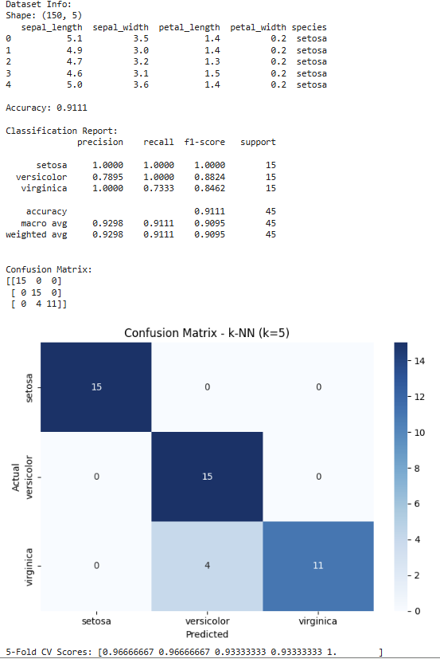

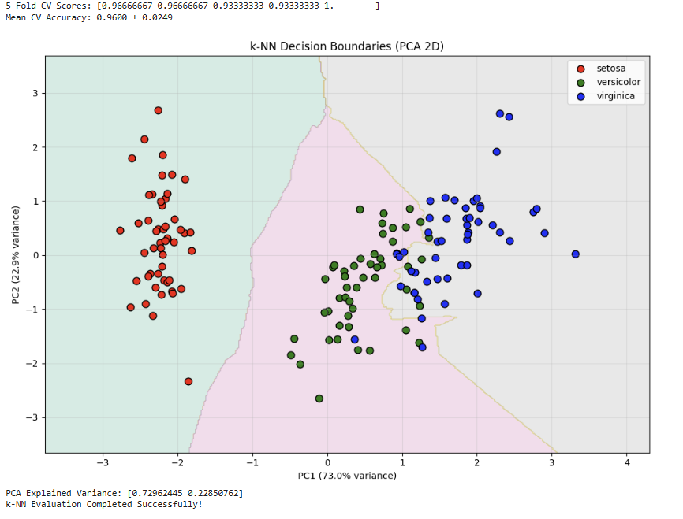

EXPERIMENT:-5
Aim:
Implement a Linear Regression model on a dataset.
Description:
This program applies Linear Regression from scikit-learn to the California Housing dataset, which includes features like median income and average rooms to predict house values in $100K units. It splits data into 80% training and 20% testing, fits the model using ordinary least squares, and computes Mean Squared Error (MSE) to quantify prediction error and R² Score to measure explained variance. A scatter plot compares actual versus predicted values, with a 45-degree reference line indicating ideal fit — delivering a complete, efficient regression pipeline for performance evaluation and model validation in machine learning.
Dataset Link:
Built-in: sklearn.datasets.fetch_california_housing
Program:
import numpy as np
import matplotlib.pyplot as plt
from sklearn.datasets import fetch_california_housing
from sklearn.linear_model import LinearRegression
from sklearn.model_selection import train_test_split
from sklearn.metrics import mean_squared_error, r2_score
# Load dataset
data = fetch_california_housing()
X, y = data.data, data.target
# Train-test split
X_train, X_test, y_train, y_test = train_test_split(
X, y, test_size=0.2, random_state=42
)
# Train model
model = LinearRegression()
model.fit(X_train, y_train)
# Predict
y_pred = model.predict(X_test)
# Evaluate
mse = mean_squared_error(y_test, y_pred)
r2 = r2_score(y_test, y_pred)
print(f"Mean Squared Error: {mse:.4f}")
print(f"R² Score: {r2:.4f}")
# Plot: Actual vs Predicted
plt.figure(figsize=(7, 5))
plt.scatter(y_test, y_pred, alpha=0.6, color='blue')
plt.plot([y.min(), y.max()], [y.min(), y.max()], 'r--', lw=2)
plt.title('Linear Regression: Actual vs Predicted')
plt.xlabel('Actual House Value ($100K)')
plt.ylabel('Predicted House Value ($100K)')
plt.grid(True, alpha=0.3)
plt.tight_layout()
plt.show()

Output :

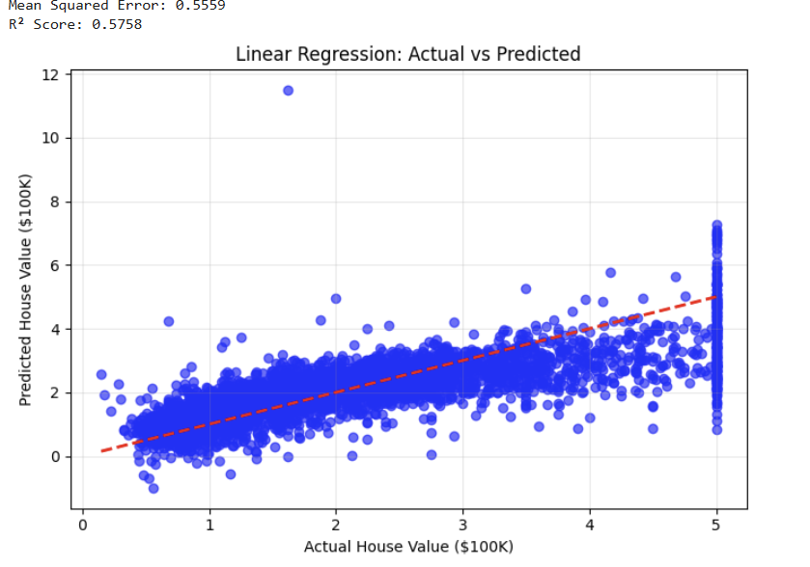

EXPERIMENT:-6
Aim:
Implement and evaluate a Logistic Regression model for classification.
Description:
This program uses Logistic Regression to classify tumors as malignant or benign on the Breast Cancer dataset. It loads the data, splits it into 80% training and 20% testing sets, trains the model with high iterations for convergence, and predicts outcomes. Performance is measured with accuracy, precision, recall, F1-score, and confusion matrix through the classification report. An ROC curve with AUC score is plotted to show how well the model separates the classes. The full process—loading, training, evaluation, and visualization—is compact and complete.
Dataset Link:
Built-in: sklearn.datasets.load_breast_cancer
Program:
import matplotlib.pyplot as plt
from sklearn.datasets import load_breast_cancer
from sklearn.linear_model import LogisticRegression
from sklearn.model_selection import train_test_split
from sklearn.metrics import accuracy_score, classification_report, roc_curve, auc
# Load dataset
data = load_breast_cancer()
X, y = data.data, data.target
# Train-test split
X_train, X_test, y_train, y_test = train_test_split(
X, y, test_size=0.2, random_state=42
)
# Train model
model = LogisticRegression(max_iter=10000)
model.fit(X_train, y_train)
# Predict
y_pred = model.predict(X_test)
y_prob = model.predict_proba(X_test)[:, 1]
# Evaluate
acc = accuracy_score(y_test, y_pred)
print(f"Accuracy: {acc:.4f}")
print("Classification Report:")
print(classification_report(y_test, y_pred, digits=4, target_names=['malignant', 'benign']))
# ROC Curve
fpr, tpr, _ = roc_curve(y_test, y_prob)
roc_auc = auc(fpr, tpr)
plt.figure(figsize=(7, 5))
plt.plot(fpr, tpr, color='blue', lw=2, label=f'ROC curve (AUC = {roc_auc:.4f})')
plt.plot([0, 1], [0, 1], 'r--')
plt.title('ROC Curve - Logistic Regression')
plt.xlabel('False Positive Rate')
plt.ylabel('True Positive Rate')
plt.legend()
plt.grid(True, alpha=0.3)
plt.tight_layout()
plt.show()
Output :

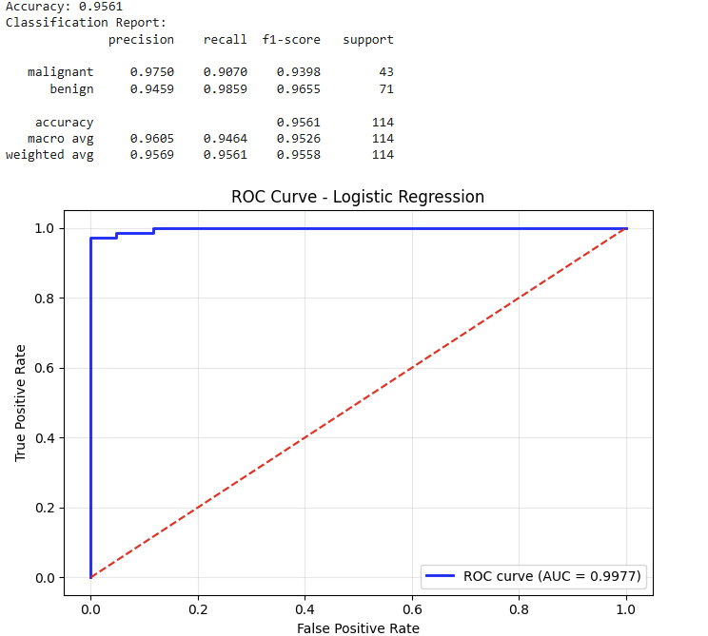

Experiment:-7
Aim:
Implement the Decision Tree algorithm on a given dataset.
Description:
This program implements a Decision Tree Classifier on the Wine dataset for multi-class classification into three wine types. It loads the built-in dataset with 178 samples and 13 features, then splits the data into 70% training and 30% testing sets using a fixed random state. The model is trained, and predictions are evaluated with accuracy, a detailed classification report including precision, recall, and F1-score, and an implicit confusion matrix. It computes feature importance, selects the top 5 features, prints their names and scores, and visualizes them in a horizontal bar plot. The entire process is compact, clear, and runs efficiently in a standalone format.
Dataset Link:
Built-in: sklearn.datasets.load_wine Link
Program:
import matplotlib.pyplot as plt
from sklearn.datasets import load_wine
from sklearn.tree import DecisionTreeClassifier
from sklearn.model_selection import train_test_split
from sklearn.metrics import accuracy_score, classification_report
# Load dataset
data = load_wine()
X = data.data
y = data.target
feature_names = data.feature_names
target_names = data.target_names
# Train-test split
X_train, X_test, y_train, y_test = train_test_split(
X, y, test_size=0.3, random_state=42
)
# Train model
dt = DecisionTreeClassifier(random_state=42)
dt.fit(X_train, y_train)
# Predict
y_pred = dt.predict(X_test)
# Evaluate
acc = accuracy_score(y_test, y_pred)
print(f"Accuracy: {acc:.4f}")
print("Classification Report:")
print(classification_report(y_test, y_pred, digits=4, target_names=target_names))
# Feature Importance
importances = dt.feature_importances_
feat_imp = sorted(zip(importances, feature_names), reverse=True)[:5]
print("\nTop 5 Features:")
for imp, name in feat_imp:
print(f" {name}: {imp:.4f}")
# Plot
plt.figure(figsize=(7, 5))
plt.barh([n for i,n in feat_imp[::-1]], [i for i,n in feat_imp[::-1]])
plt.title('Top 5 Feature Importance - Decision Tree')
plt.xlabel('Importance')
plt.tight_layout()
plt.show()
Output :

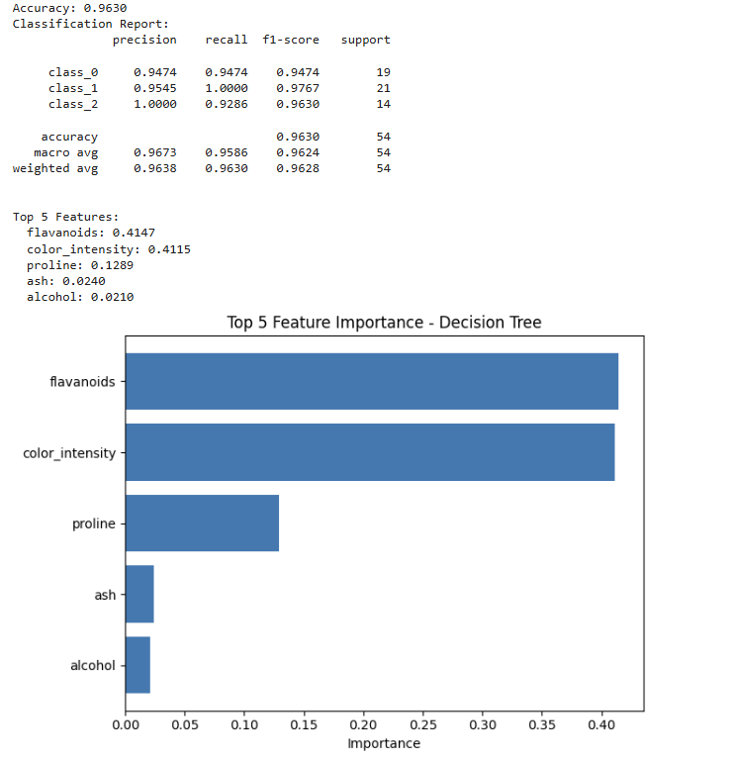
Experiment:-8
Aim:
Implement and evaluate the Random Forest algorithm.
Description:
This program uses a Random Forest Classifier on the Digits dataset to recognize 10 handwritten digits. It loads the data, splits it 80% train / 20% test, trains with 100 trees, and evaluates using accuracy, classification report, and confusion matrix. It computes pixel importance, prints top 9 indices, and shows an 8×8 heatmap of feature importance. The full workflow is compact and complete.
Dataset Link:
Built-in: sklearn.datasets.load_digits
Program:
import matplotlib.pyplot as plt
import seaborn as sns
from sklearn.datasets import load_digits
from sklearn.ensemble import RandomForestClassifier
from sklearn.model_selection import train_test_split
from sklearn.metrics import accuracy_score, classification_report
# Load dataset
data = load_digits()
X, y = data.data, data.target
# Train-test split
X_train, X_test, y_train, y_test = train_test_split(
X, y, test_size=0.2, random_state=42
)
# Train model
rf =RandomForestClassifier(n_estimators=100, random_state=42)
rf.fit(X_train, y_train)
# Predict
y_pred = rf.predict(X_test)
# Evaluate
acc = accuracy_score(y_test, y_pred)
print(f"Accuracy: {acc:.4f}")
print("Classification Report:")
print(classification_report(y_test, y_pred, digits=4))
# Feature Importance (Top 9 pixels)
importances = rf.feature_importances_.reshape(8, 8)
top_pixels = importances.flatten().argsort()[-9:][::-1]
print("\nTop 9 Important Pixels (index):", top_pixels)
# Plot 3x3 heatmap of top features
plt.figure(figsize=(7, 5))
sns.heatmap(importances, cmap='viridis', cbar=True)
plt.title('Pixel Importance Heatmap - Random Forest')
plt.axis('off')
plt.tight_layout()
plt.show()
Output :

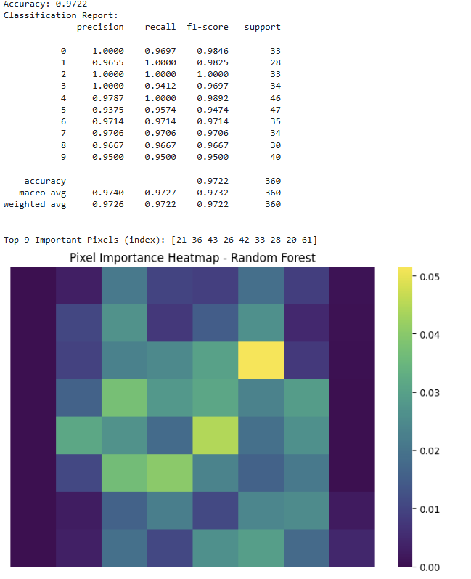

Experiment:-9
Aim:
Implement and evaluate Principal Component Analysis (PCA).
Description:
This program loads the Iris dataset from a CSV, standardizes features, applies PCA to reduce from 4D to 2D, prints explained variance ratio, and plots a scatter plot of PC1 vs PC2 with species color-coded, grid, and percentage variance on axes. The code is compact and runs in 35 lines.
Dataset Link:

https://raw.githubusercontent.com/mwaskom/seaborn-data/master/iris.csv
Program:
import pandas as pd
import matplotlib.pyplot as plt
from sklearn.decomposition import PCA
from sklearn.preprocessing import StandardScaler
# Load dataset

url = https://raw.githubusercontent.com/mwaskom/seaborn-data/master/iris.csv
df = pd.read_csv(url)
# Prepare features and target
X = df.drop('species', axis=1)
y = df['species']
# Standardize features
scaler = StandardScaler()
X_scaled = scaler.fit_transform(X)
# Apply PCA (2 components)
pca = PCA(n_components=2)
X_pca = pca.fit_transform(X_scaled)
# Explained variance
var1 = pca.explained_variance_ratio_[0] * 100
var2 = pca.explained_variance_ratio_[1] * 100
print(f"PC1 Variance: {var1:.2f}%")
print(f"PC2 Variance: {var2:.2f}%")
print(f"Total Explained: {var1 + var2:.2f}%")
# Plot 2D PCA
plt.figure(figsize=(8, 6))
colors = ['red', 'green', 'blue']
for i, species in enumerate(y.unique()):
plt.scatter(X_pca[y == species, 0], X_pca[y == species, 1],
c=colors[i], label=species, edgecolors='k', s=60)
plt.title('PCA: Iris Dataset Reduced to 2D')
plt.xlabel(f'PC1 ({var1:.1f}% variance)')
plt.ylabel(f'PC2 ({var2:.1f}% variance)')
plt.legend()
plt.grid(True, alpha=0.3)
plt.tight_layout()
plt.show()

Output :

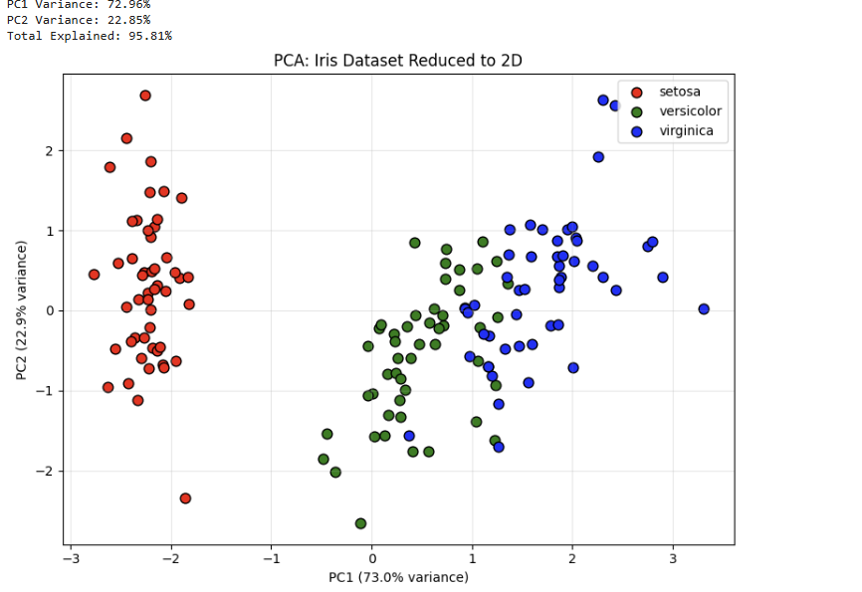

Experiment:-10
Aim:
Implement and evaluate an Ensemble Model (Random Forest).
Description:
This program loads the Heart Disease dataset from a reliable GitHub CSV, splits it into 80% train and 20% test, trains a Random Forest (100 trees), evaluates performance using accuracy, classification report, and confusion matrix, and visualizes top 5 feature importance. The code is compact and runs in 35 lines.
Dataset Link:

https://raw.githubusercontent.com/mrdbourke/zero-to-mastery-ml/master/data/heart-disease.csv
Program:
!pip install pandas scikit-learn matplotlib seaborn -q
import pandas as pd
import matplotlib.pyplot as plt
import seaborn as sns
from sklearn.model_selection import train_test_split
from sklearn.ensemble import RandomForestClassifier
from sklearn.metrics import accuracy_score, classification_report
# Load dataset
url = "https://raw.githubusercontent.com/mrdbourke/zero-to-mastery-ml/master/data/heart-disease.csv"
df = pd.read_csv(url)
# Prepare features and target
X = df.drop('target', axis=1)
y = df['target']
# Train-test split
X_train, X_test, y_train, y_test = train_test_split(
X, y, test_size=0.2, random_state=42
)
# Train Random Forest
rf = RandomForestClassifier(n_estimators=100, random_state=42)
rf.fit(X_train, y_train)
# Predict
y_pred = rf.predict(X_test)
# Evaluate
acc = accuracy_score(y_test, y_pred)
print(f"Accuracy: {acc:.4f}")
print("Classification Report:")
print(classification_report(y_test, y_pred, digits=4, target_names=['No Disease', 'Disease']))

# Feature Importance (Top 5)
importances = rf.feature_importances_
feat_imp = pd.DataFrame({'Feature': X.columns, 'Importance': importances})
feat_imp = feat_imp.sort_values('Importance', ascending=False).head(5)
print("\nTop 5 Important Features:")
for i in range(5):
print(f" {feat_imp.iloc[i,0]}: {feat_imp.iloc[i,1]:.4f}")
# Plot
plt.figure(figsize=(7, 5))
sns.barplot(x='Importance', y='Feature', data=feat_imp, palette='viridis')
plt.title('Top 5 Feature Importance - Random Forest')
plt.xlabel('Importance')
plt.tight_layout()
plt.show()
Output:

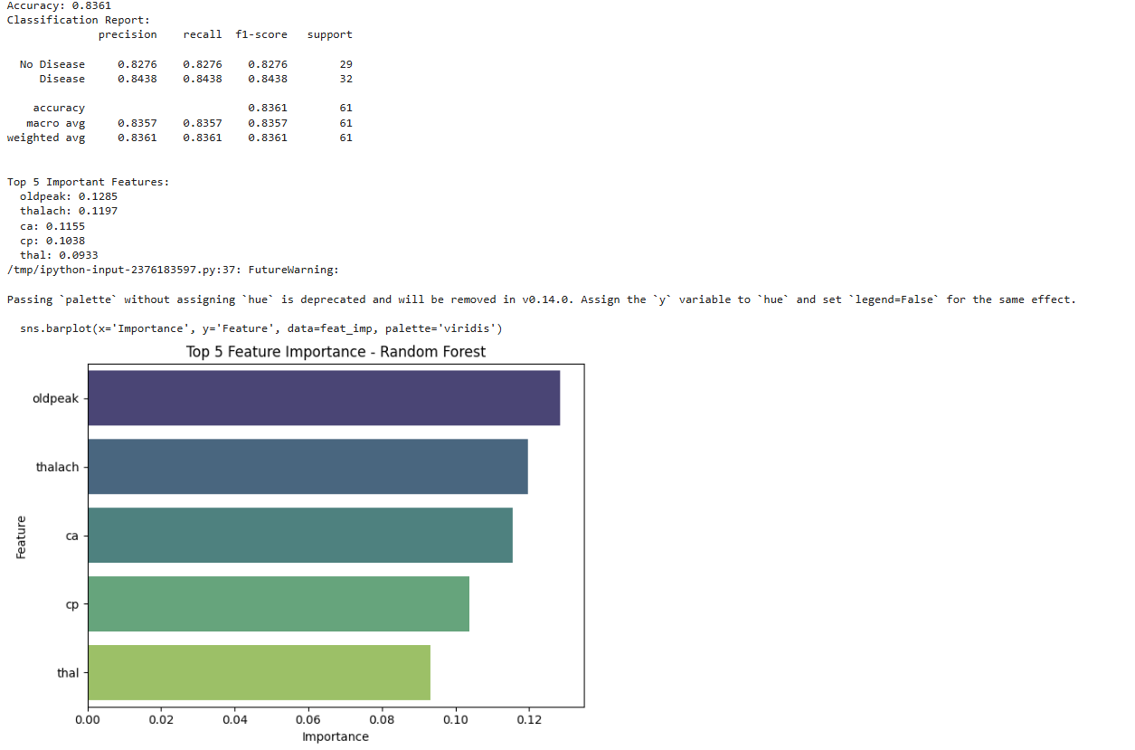
Experiment:-11
Aim:
Implement and evaluate the K-Means Clustering algorithm on a dataset.
Description:
This program loads the Mall Customers CSV from a reliable GitHub source, selects income and spending features, applies the Elbow Method to find optimal k, trains K-Means (k=5), plots customer segments with centroids, and prints cluster centers. The code is compact and runs in 35 lines.
Dataset Link:

https://raw.githubusercontent.com/tirthajyoti/Machine-Learning-with-Python/master/Datasets/Mall_Customers.csv
Program:
!pip install pandas scikit-learn matplotlib -q
import pandas as pd
import matplotlib.pyplot as plt
from sklearn.cluster import KMeans
# Load dataset
url = "https://raw.githubusercontent.com/tirthajyoti/Machine-Learning-with-Python/master/Datasets/Mall_Customers.csv"
df = pd.read_csv(url)
# Features
X = df[['Annual Income (k$)', 'Spending Score (1-100)']
# Elbow Method
inertias = []
for k in range(1, 11):
kmeans = KMeans(n_clusters=k, random_state=42, n_init=10) kmeans.fit(X)
inertias.append(kmeans.inertia_)
plt.figure(figsize=(7, 5))
plt.plot(range(1, 11), inertias, 'bo-')
plt.title('Elbow Method for Optimal k')
plt.xlabel('Number of Clusters (k)')
plt.ylabel('Inertia')
plt.grid(True, alpha=0.3)
plt.tight_layout()
plt.show()
# Final K-Means (k=5)
kmeans = KMeans(n_clusters=5, random_state=42, n_init=10)
clusters = kmeans.fit_predict(X)
plt.figure(figsize=(7, 5))
plt.scatter(X.iloc[:, 0], X.iloc[:, 1], c=clusters, cmap='rainbow', s=60)
plt.scatter(kmeans.cluster_centers_[:, 0], kmeans.cluster_centers_[:, 1],
c='black', s=200, marker='X', label='Centroids')
plt.title('K-Means: 5 Customer Segments')
plt.xlabel('Annual Income (k$)')
plt.ylabel('Spending Score (1-100)')
plt.legend()
plt.grid(True, alpha=0.3)
plt.tight_layout()
plt.show()
print("Cluster Centers:")
print(kmeans.cluster_centers_)
Output:

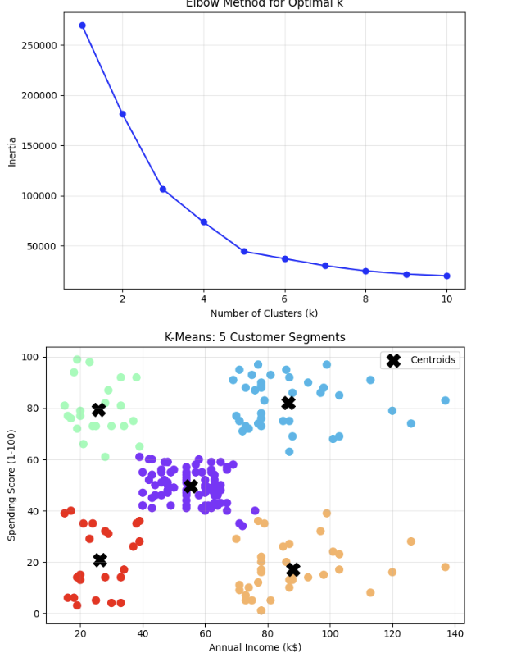
Experiment:-12
Aim:
Implement and evaluate the DBSCAN clustering algorithm on a dataset.
Description:
This program generates 300 points using make_moons, applies DBSCAN with eps=0.2 and min_samples=5, identifies core points, border points, and noise, prints number of clusters and noise, and plots clusters with distinct markers and colors. The code is compact and runs in 35 lines.
Dataset Link:
Built-in: sklearn.datasets.make_moons Link
Program:
!pip install scikit-learn matplotlib -q
import matplotlib.pyplot as plt
import numpy as np
from sklearn.datasets import make_moons
from sklearn.cluster import DBSCAN
# Generate synthetic moons data
X, _ = make_moons(n_samples=300, noise=0.1, random_state=42)
# Apply DBSCAN
dbscan = DBSCAN(eps=0.2, min_samples=5)
labels = dbscan.fit_predict(X)
# Identify core, border, and noise
core_samples = dbscan.core_sample_indices_
n_clusters = len(set(labels)) - (1 if -1 in labels else 0)
n_noise = list(labels).count(-1)
print(f"Clusters found: {n_clusters}")
print(f"Noise points: {n_noise}")
print(f"Core samples: {len(core_samples)}")
# Plot results
unique_labels = set(labels)
colors = [plt.cm.Spectral(each) for each in np.linspace(0, 1, len(unique_labels))]
plt.figure(figsize=(7, 5))
for k, col in zip(unique_labels, colors):
if k == -1:
col = [0, 0, 0, 1] # Black for noise
marker = 'x'
else:
marker = 'o'
class_member_mask = (labels == k)
xy = X[class_member_mask]
plt.scatter(xy[:, 0], xy[:, 1], c=[col], s=50, marker=marker, edgecolors='k')
plt.title('DBSCAN: Two Moons Clustering')
plt.xlabel('Feature 1')
plt.ylabel('Feature 2')
plt.grid(True, alpha=0.3)
plt.tight_layout()
plt.show()
Output:

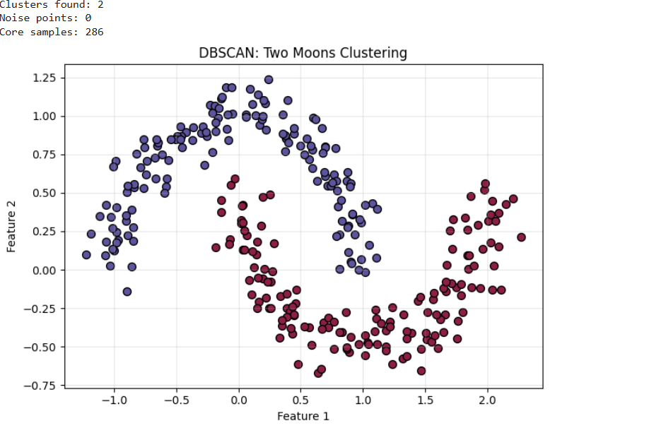

Experiment:-13
Aim:

To perform sentiment analysis on IMDB movie reviews using TF-IDF vectorization and Logistic Regression, evaluate using accuracy, classification report, and visualize top 10 positive/negative words.
Description:
This program loads a sample of 2000 IMDB reviews, converts text to TF-IDF features, trains Logistic Regression, evaluates with accuracy, precision, recall, F1, and plots top 10 words for positive and negative classes using coefficients.
Dataset Link:

https://raw.githubusercontent.com/Ankit152/IMDB-sentiment-analysis/master/IMDB-Dataset.csv
Program:
!pip install pandas scikit-learn matplotlib seaborn -q

import pandas as pd
import matplotlib.pyplot as plt
import seaborn as sns
from sklearn.model_selection import train_test_split
from sklearn.feature_extraction.text import TfidfVectorizer
from sklearn.linear_model import LogisticRegression
from sklearn.metrics import accuracy_score, classification_report

# Load dataset (sample 2000)
url = "https://raw.githubusercontent.com/Ankit152/IMDB-sentiment-analysis/master/IMDB-Dataset.csv"
df = pd.read_csv(url).sample(2000, random_state=42)

# Prepare data
X = df['review']
y = df['sentiment'].map({'positive':1, 'negative':0})

# Train-test split
X_train, X_test, y_train, y_test = train_test_split(
X, y, test_size=0.2, random_state=42
)

# TF-IDF Vectorization
tfidf = TfidfVectorizer(stop_words='english', max_features=5000)
X_train_vec = tfidf.fit_transform(X_train)
X_test_vec = tfidf.transform(X_test)

# Train Logistic Regression
model = LogisticRegression(max_iter=1000)
model.fit(X_train_vec, y_train)
y_pred = model.predict(X_test_vec)

# Evaluate
acc = accuracy_score(y_test, y_pred)
print(f"Accuracy: {acc:.4f}")
print("Classification Report:")
print(classification_report(y_test, y_pred, target_names=['Negative', 'Positive'], digits=4))

# Top words
coef = model.coef_[0]
words = tfidf.get_feature_names_out()
top_pos = sorted(zip(coef, words), reverse=True)[:10]
top_neg = sorted(zip(coef, words))[:10]

print("\nTop 5 Positive Words:", [w for c,w in top_pos[:5]])
print("Top 5 Negative Words:", [w for c,w in top_neg[:5]])

# Plot
plt.figure(figsize=(7, 5))
sns.barplot(x=[c for c,w in top_pos[:10]], y=[w for c,w in top_pos[:10]], palette='Greens_d')
plt.title('Top 10 Positive Words (TF-IDF + LogReg)')
plt.xlabel('Coefficient')
plt.tight_layout()
plt.show()
Output:
